Software Requirements Specification

for

Property Plus

Prepared by

Group Name: *TheBestGroupAlive*

|  |  |  |
| --- | --- | --- |
| Nixon Thao | 00340990 | ncthao@email.uscupstate.edu |
| Blake | 00408115 | bab6@email.uscupstate.edu |
| Komal Mehta | 01146265 | mehtakj@email.uscupstate.edu |
| Le Minh MaI | 00239768 | lmai@email.uscupstate.edu |
|  |  |  |
|  |  |  |

|  |  |
| --- | --- |
| Instructor: | Amanda Shwartz |
| Course: | Software Engineering CSCI-U540-01V |
| Date: | 11/18/20 |

|  |  |
| --- | --- |
|  |  |

Contents

1 Introduction................................................................................................................................ 1

1.1 Product Purpose................................................................................................................... 1

1.2 Intended Audience and Document Overview.................................................................. 1

1.3 Definitions, Acronyms and Abbreviations...................................................................... 1

2 Overall Description............................................................................................................... 2

2.1 Product Perspective..........................................................................................................2

2.2 Product Functionality......................................................................................................... 2

2.3 Users and Characteristics................................................................................................. 2

2.4 Operating Environment......................................................................................................2

2.5 User Documentation............................................................................................................. 3

2.6 Assumptions and Dependencies.......................................................................................3

3 Specific Requirements.......................................................................................................... 4

3.1 User Interfaces and Functional Requirements........................................................... 4

3.2 Hardware Interfaces............................................................................................................ 4

4 Other Non-functional Requirements........................................................................ 5

4.1 Performance Requirements............................................................................................... 5

4.2 Safety and Security Requirements.................................................................................. 5

4.3 Software Quality Attributes............................................................................................. 5

5 Other Requirements............................................................................................................... 6

# 

# 

# *<In this template you will find text bounded by the “<>” symbols. This text appears in italics and is intended to guide you through the template and provide explanations regarding the different sections in this document. There are two types of comments in this document. The comments that are in black are intended specifically for this course. The comments that are in blue are more general and apply to any SRS.* ***Please, make sure to delete all of the comments before submitting the document.***

# *The explanations provided below, do not cover all of the material, but merely, the general nature of the information you would usually find in SRS documents. It is based on the IEEE requirements and was adapted specifically for the needs of the Software Engineering course. Some sections in this document are required for your group to complete, and other sections are optional. Optional sections will be explicitly marked as optional.*

# **1** **Introduction**

## **1.1** **Product Purpose**

This document is intended to describe the functionality of a portal for a property management web-based application. These functionalities would include actions like managing properties (update existing property, add/remove properties), manage lease’s (add/remove lease, update existing lease) and manage maintenance requests (communicate with the lease and forward requests to the administrator). This software will provide a bridge for real estate owners and their tenants. The tenants will be able to login and logout of the system to look at their profile and access their payments or property. This software is being designed to allow tenants to easily access their property needs or change online and other features that this portal offers.

## **1.2** **Product Scope**

This software that was described in this document allows the administrators of this web-application to modify and manage the tenants properties efficiently while also providing tenants the ability to make sure their property is correct and the history of their payments in a fast and easy way.

## **1.3** **Intended Audience and Document Overview**

This document is primarily intended for tenants that are approved for one of our owner’s properties but could also reach to newcomers that would like a property managed by PropertyPlus by viewing our properties. They will have the opportunity to do the features we offer online with this software. This software system will be used by those properties that are managed by PropertyPlus.

# **2** **Overall Description**

## **2.1** **Product Perspective**

Our software is designed to be a stand-alone property management portal that is intended to be used only for PropertyPlus Properties and modified only by the administrators of this software. Our product could spread towards other properties that would want to be managed by PropertyPlus due to:

* Easy Access - Any newcomer will be able to view, save, or pay through our website with simple procedures.
* Manageable- The administrators don’t have to do much after the software is up due to the simple inputs that were made to add new properties or tenants.
* Availability- Able to view other properties that are available if tenants are interested in another or if a new user wants to find a property under us.

## **2.2** **Product Functionality**

* Provide property management functions such as add/delete/edit properties, add/delete/edit property leases, and submit/approve/delete maintenance requests from the leasers.
* Provide functions for tenants to view their property and other properties as well. The properties will include information such as the address, size in square feet, bedrooms, bathrooms, extra features, the year it was built, the monthly rate, utilities, contract time, Leaser name, owner name, and payments.
* Provide functions for tenants to contact us for any sort of maintenance request if any problem ever occurs instead of calling us.

## **2.3** **Users and Characteristics**

This software is intended for property owners that want to be represented by PropertyPlus to manage their tenants. The tenant will have limited access to what they can view and what they can do as well. The administrator shall be responsible for updating the system, approving or declining any requests, and general administration duties. The administrator does not need to be a computer expert to perform these duties but knowledge of simple data entry.

## 

## 

## 

## **2.4** **Operating Environment**

The primary operating environment for this software will be the tenants web browser interface as it will include all the features, we have made for them. The standard web browser home page will include some backstory to why they should rent from one of our properties but not anything major but show our properties and what we do.

## **2.5** **User Documentation**

The documentation will be provided on the website for the web application administrator. This software is easily modifiable so the administrators will provide some documentation on the homepage to show the new users how to access their features.

## **2.6** **Assumptions and Dependencies**

Property owners that are interested in our software will provide all their information as well as their tenants so that the administrators could input the information provided. Any tenant who wishes to use our software will have to use a device and register in the web application to use our features. It is assumed that the owners will provide documentation on every house they own as well as their tenant information. The property management software is primarily focused on the interaction between a tenant and owner through our software.

# **3** **Specific Requirements**

## **3.1** **User Interfaces and Functional Requirements**

### **3.1.1** **Use Case View**

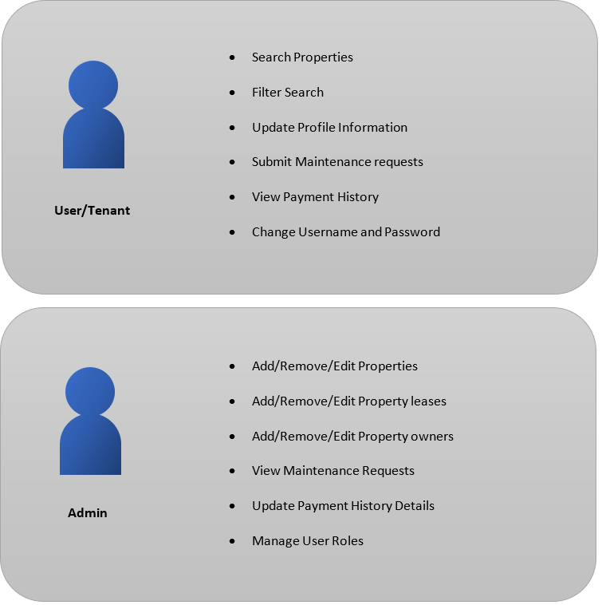

**3.1.2** **User Interfaces**

1. Main Home Page

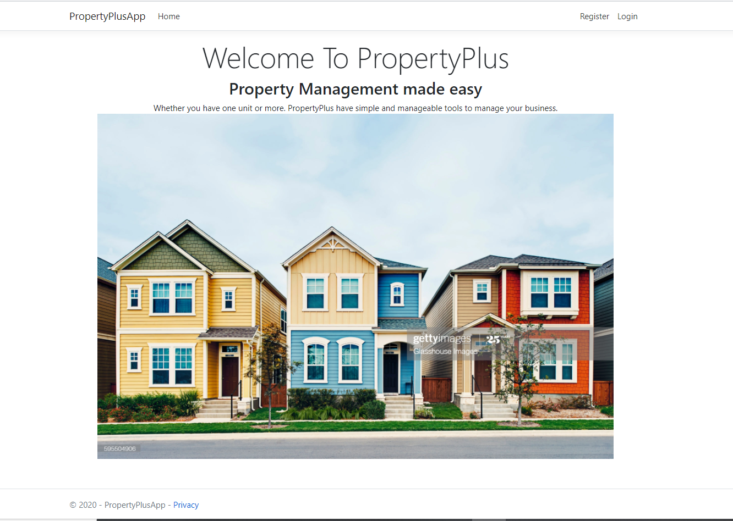

* This is the home page that will pop up when the web application is open.

1. Account Register Page

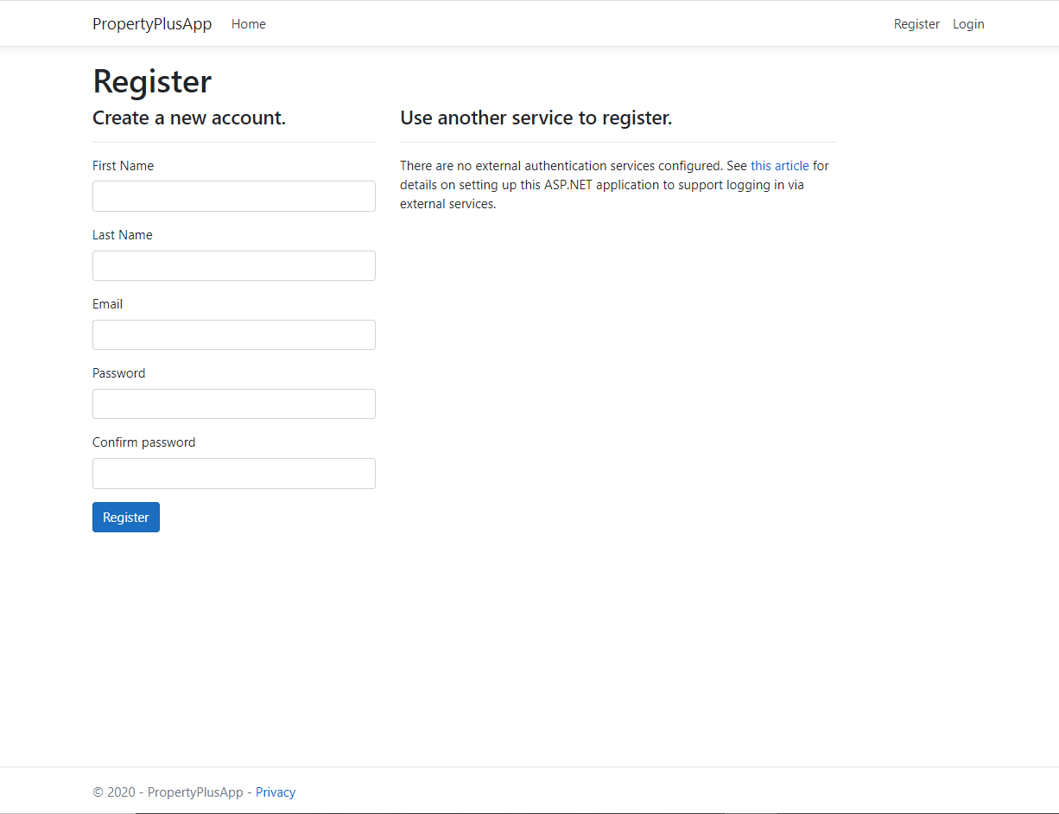

* This is what the register page will look like when a user clicks to register at the top-right. They will have the requirements of using a first and last name, email, password, and confirmation of the password.
* Each user that registers will be roled as “Basic” unless authorized to be more than that.

1. Login Page

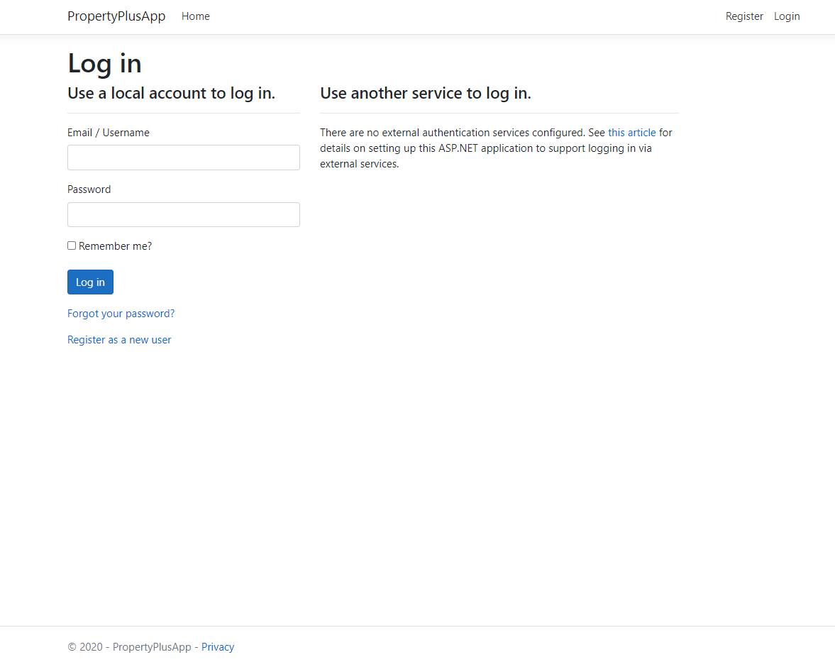

* This is the login page that comes when a user clicks Login on the top-right. The user will have to type in their login credentials such as an email or username and their password. They have the option to be remembered as well.
* The username will be provided after creating an account.

1. User/Tenant Home Page

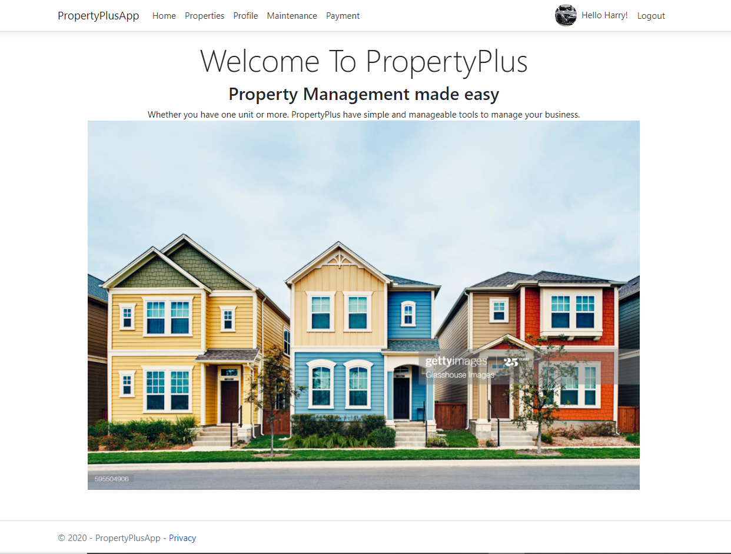

* This is the tenant home page when a user login or register. They will have the features to view their property or other properties, profile, Maintenance requests, and payments.

1. Properties Page

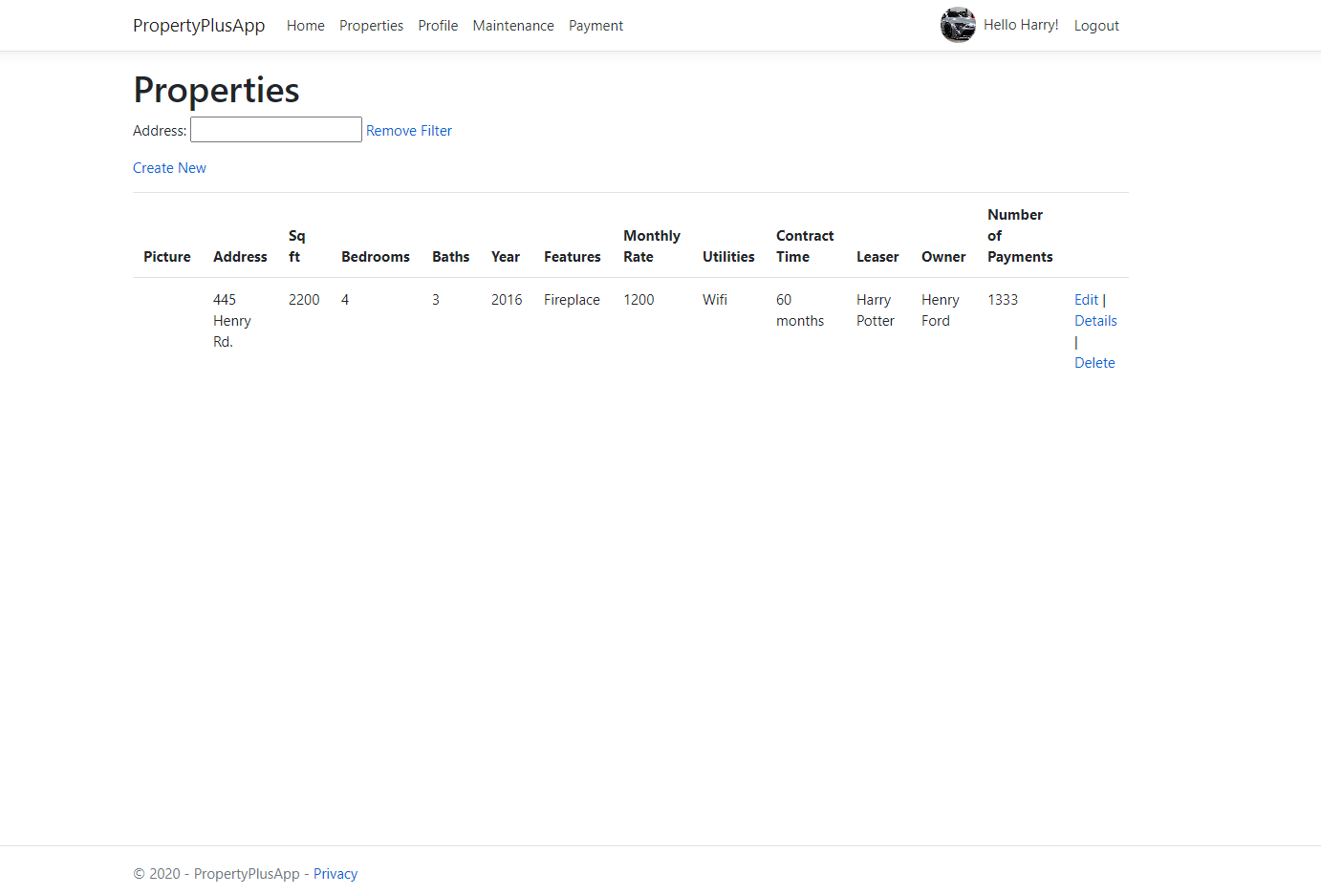

* This is the properties page when a user clicks to search for properties or find theirs.
* The search bar will find the property by filtering towards the address of the property.

1. User profile page 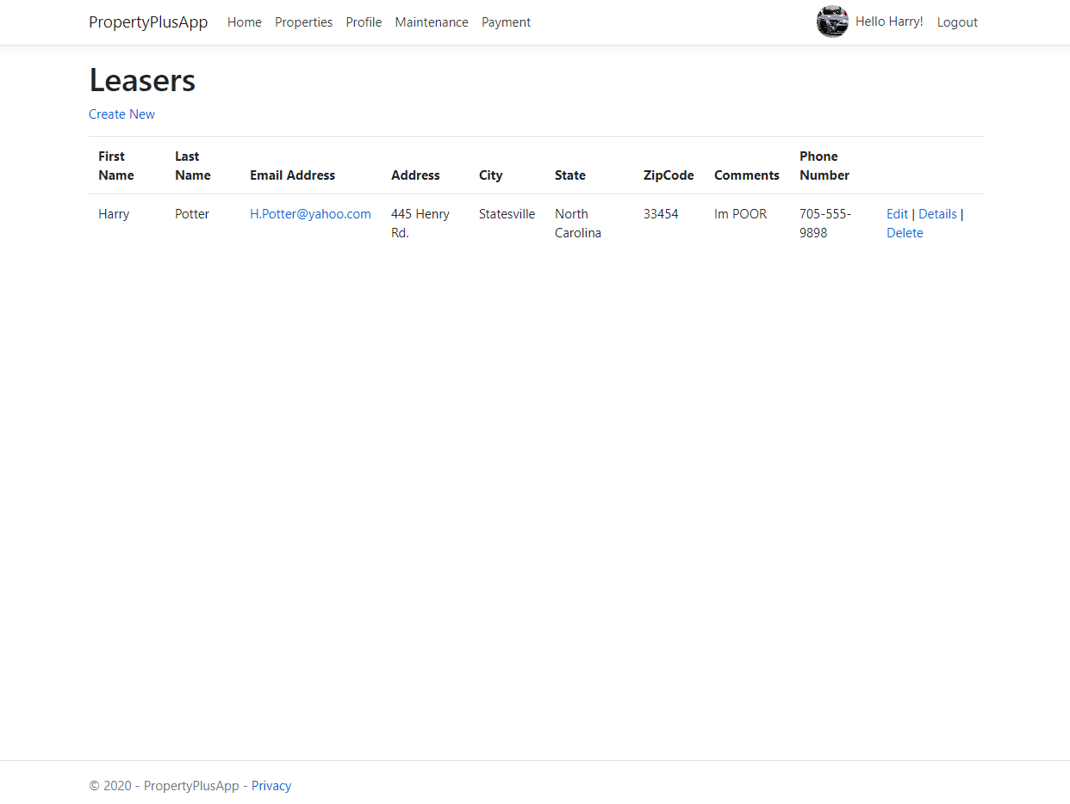

* After registering to the Property Plus, a user will have to input their information in the profile page once so that the administrators can find the user. This is how the administration database gets connected to the tenants.

1. Maintenance request page

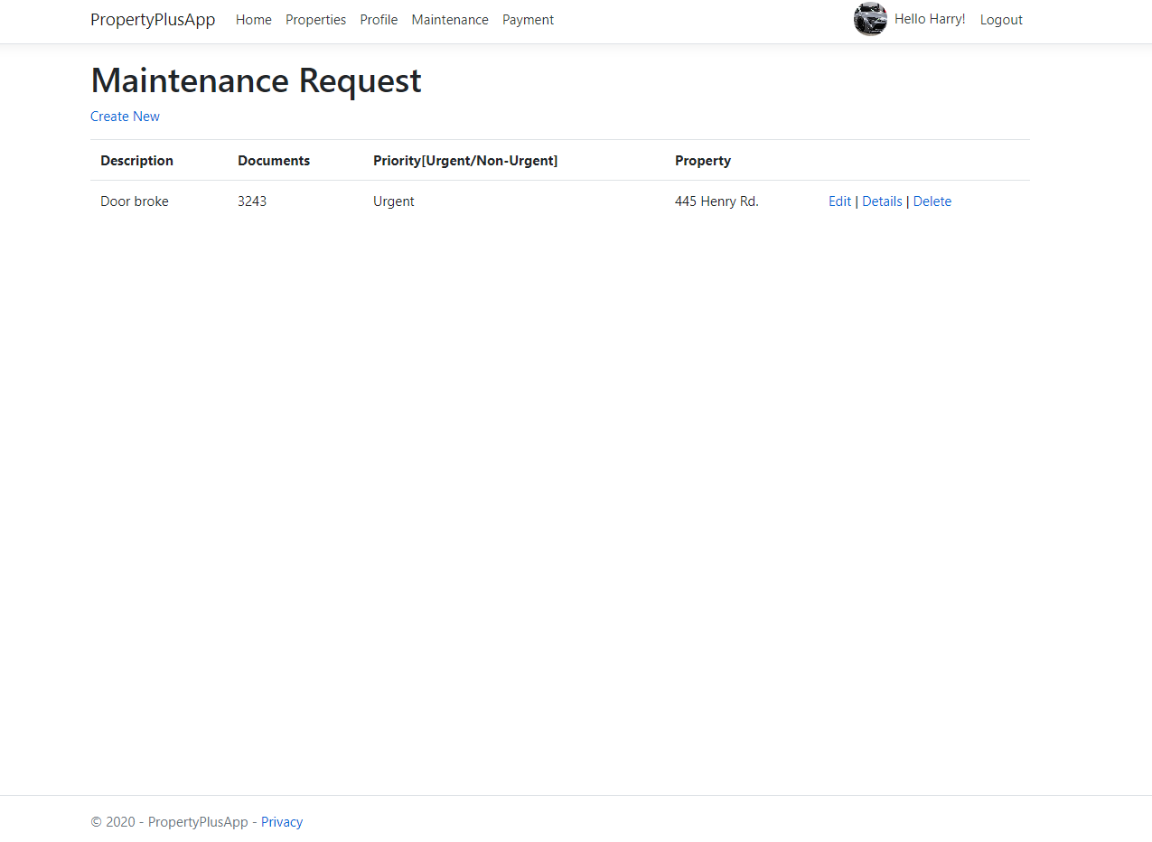

* This is the maintenance request page where the tenant will create a request form to the administrators.
* The tenant can set the priority of the request to urgent or non-urgent so that the administrator will know if it is urgent or not along what property it is at.

1. Tenant Payment History Page

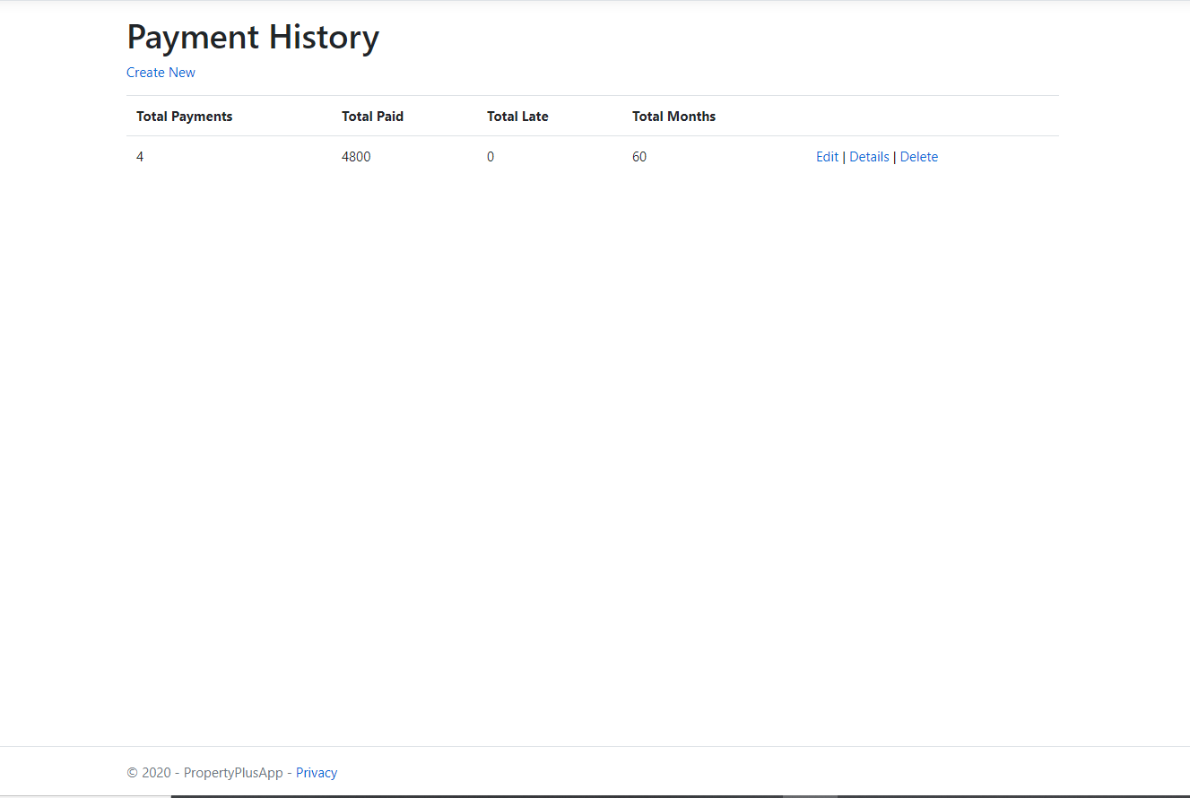

* This is the payment history page where the tenant can observe their total payments, late payments, and how long their contract is with the total months.
* The details page will give the name of the leaser to whom that specific payment information belongs.

1. User profile page

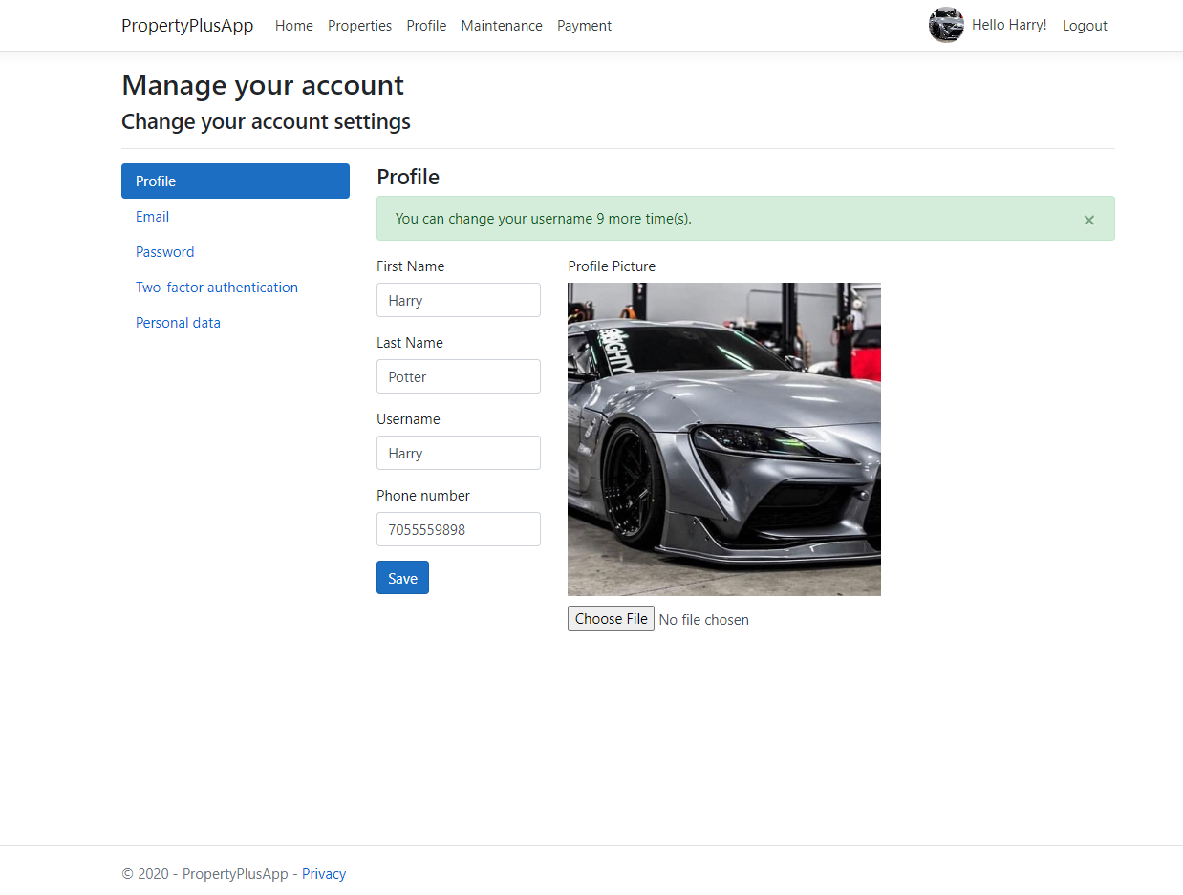

* This is the user/admin profile page where they can see their name, username, phone number, and could add a profile picture. It has a limited constraint on how many times a user can change their username. This username could be used to login.

1. Admin Home Page

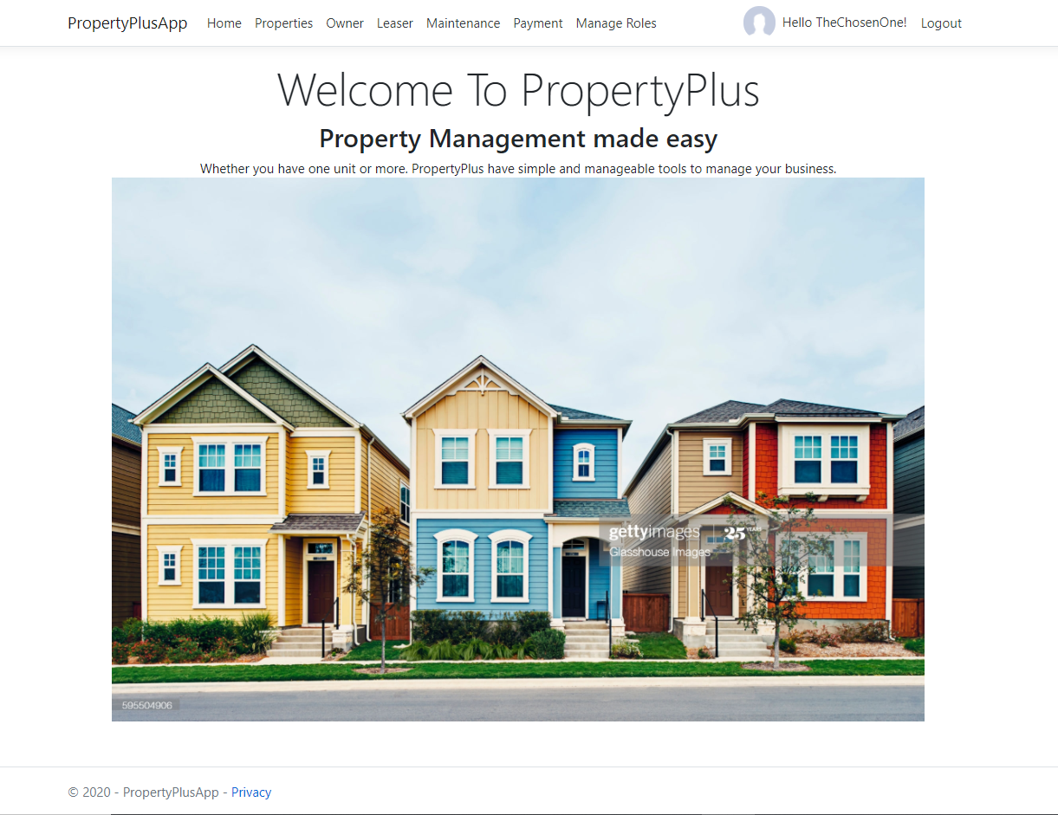

* This is the admin home page when ad admin logs in. They have the ability to add/delete/edit properties, add/delete/edit owners, add/delete/edit leases, view maintenance requests, update payments, and manage roles to users.

1. Admin Properties Page

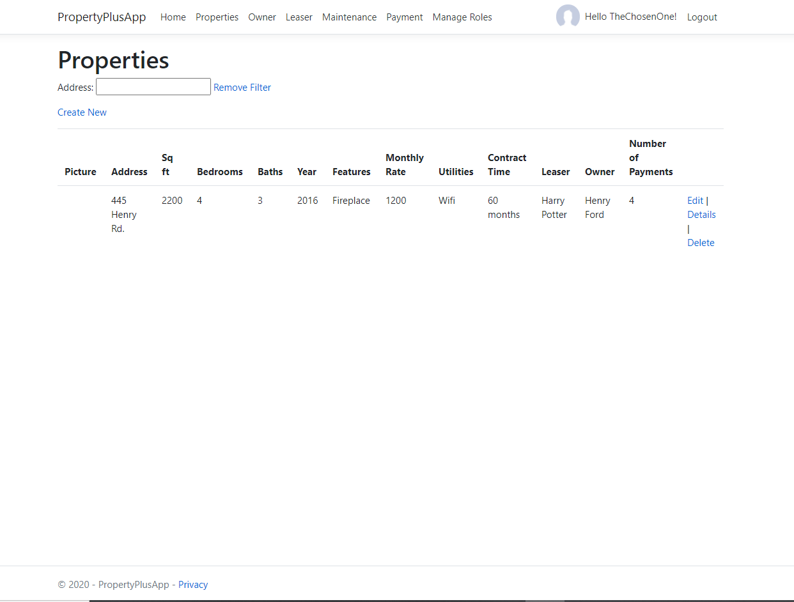

* This is the admin properties page where admins will add in new properties and show the information for each.

1. Owner’s Page

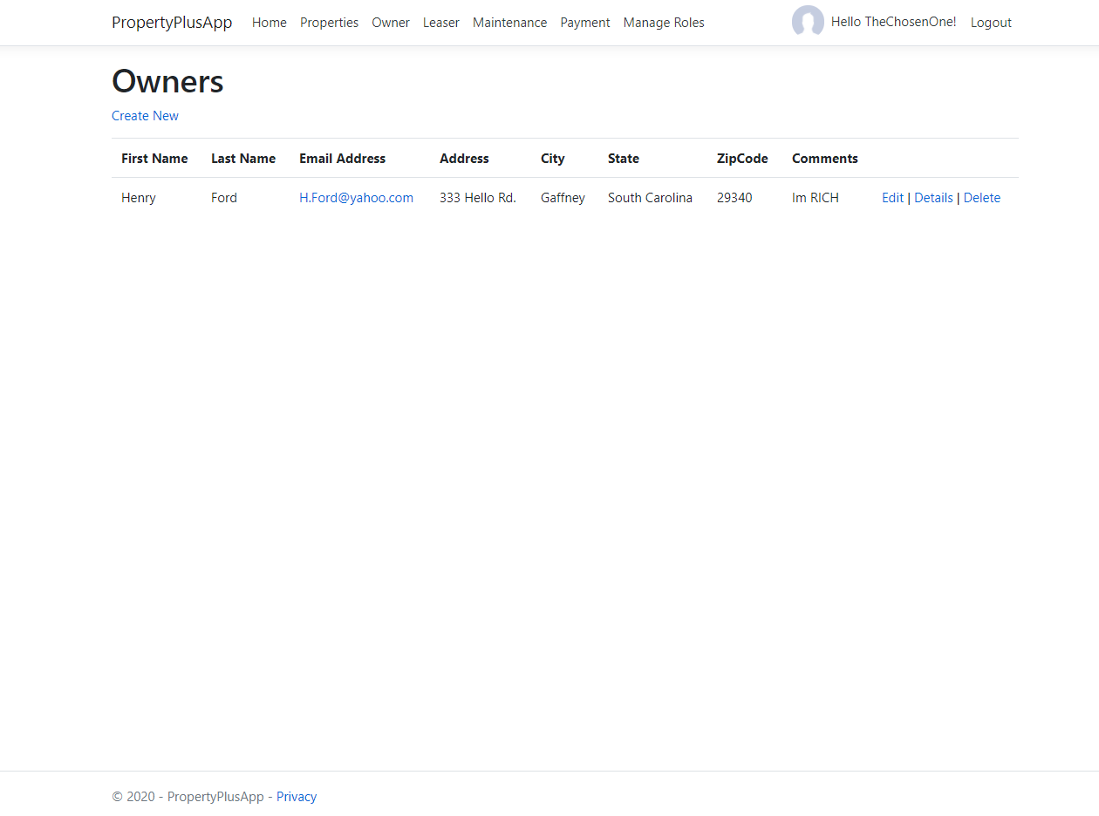

* This is the owner’s page where the property owner’s information will be provided.
* It will be a way for the administrators to get in contact with the owner if need be.
* Once registered for the portal, owner’s information has to be entered once.

1. Property Leaser Page

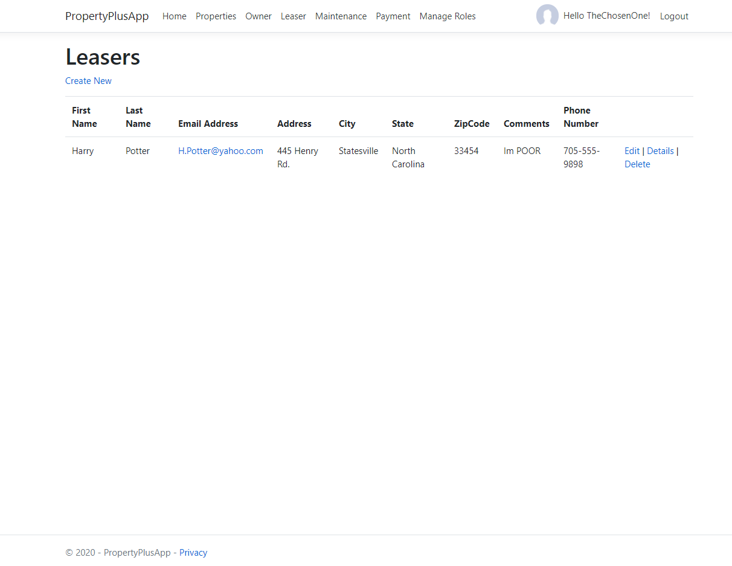

* This is the property leaser page where the administrator will have the information of the leases.

1. Admin Maintenance request page

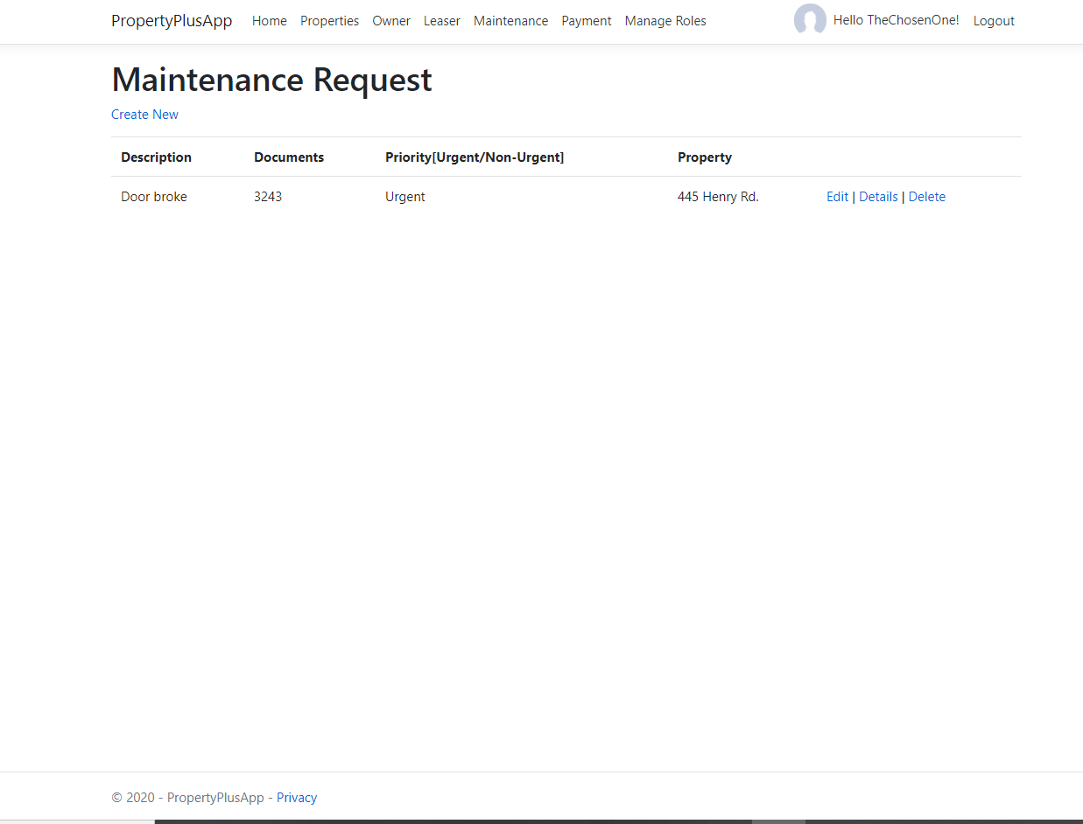

* This is the maintenance request page for the admin to view what a tenant is requesting.

1. Admin Payment Page

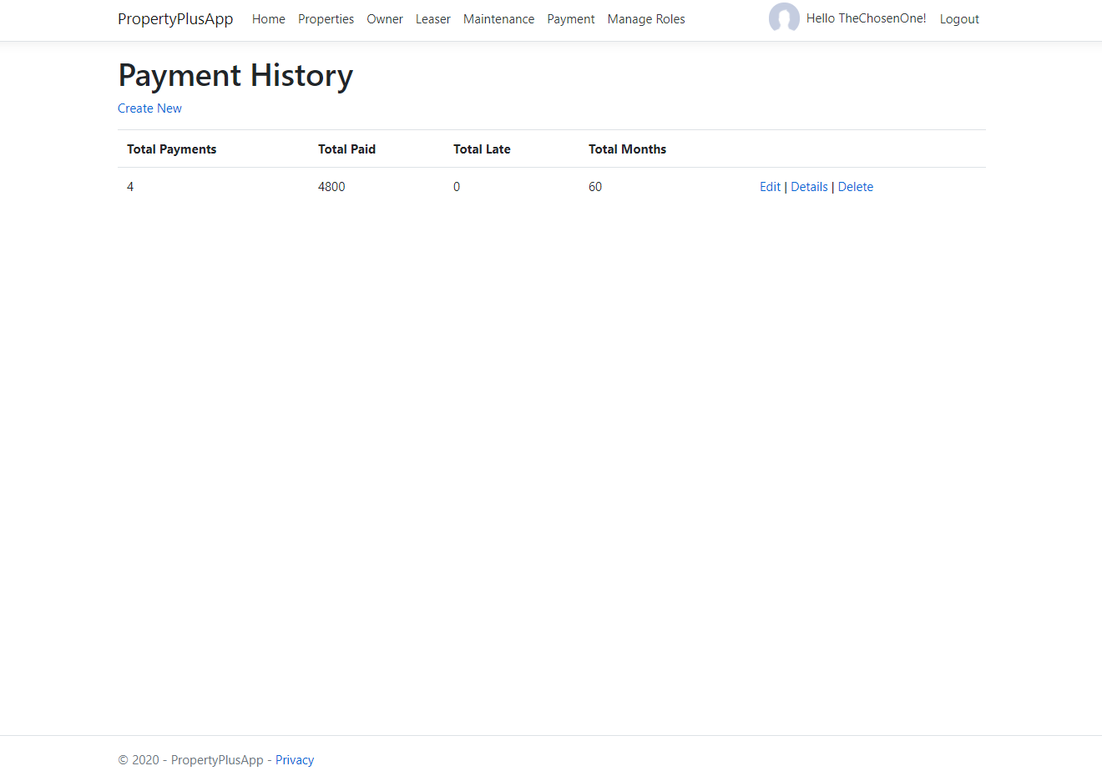

* This is the admin payment page where the admin updates the payment history of each tenant.

1. Admin manage roles page

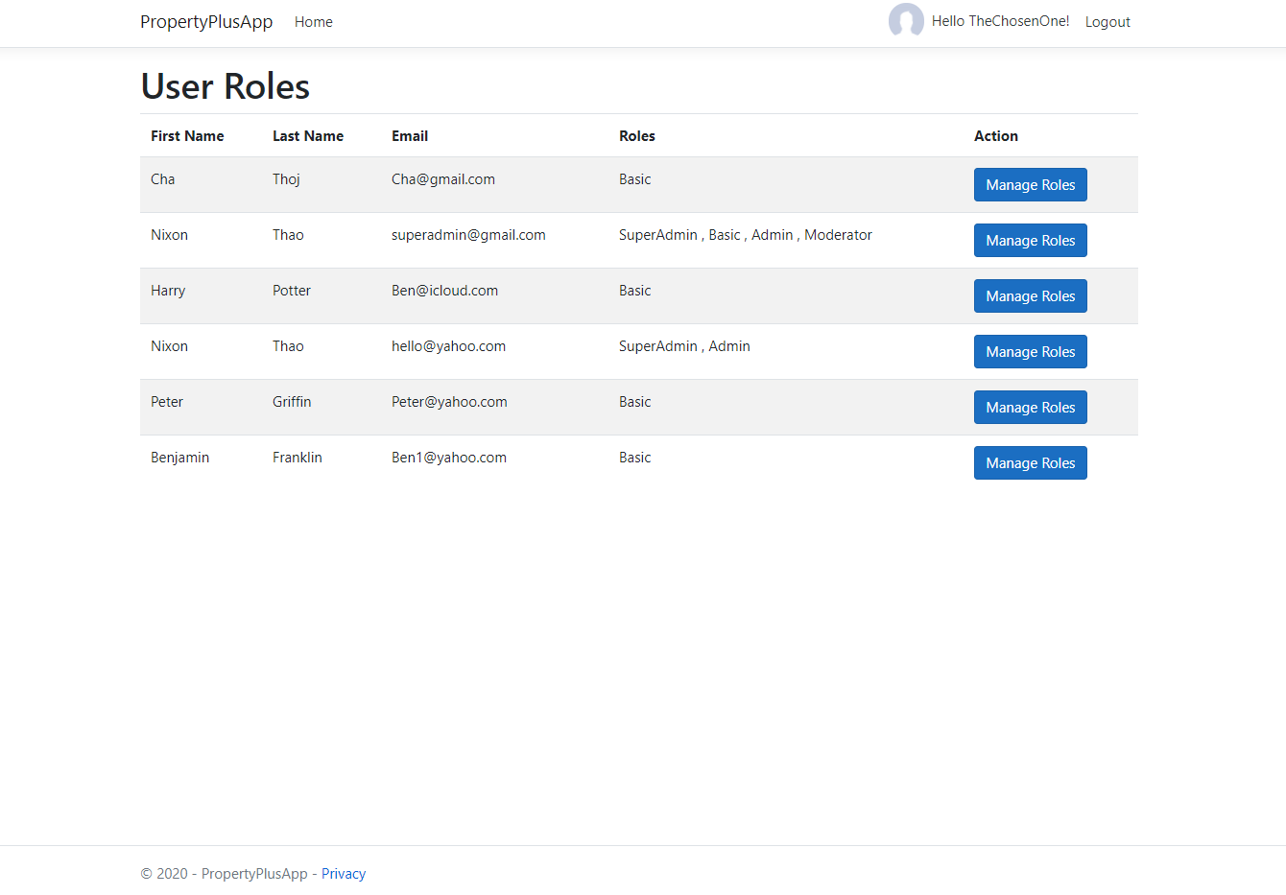

* This is where the admin will set up the roles for each user as either basic, moderator, admin, or superadmin.
* Each role has certain restrictions to what they can do or see.

# **4** **Other Non-functional Requirements**

## **4.1** **Performance Requirements**

As the renters and rentees increase their usage of the product the amount of properties and users will increase. We would like our application to support various amounts of properties without creating bottlenecks within the system. The ultimate goal of performance is to have all users, property owners and property renters have the same experience.

TODO: 1. The amount of time for a maintenance request to be available for the owner to be seen should be no greater than 30 seconds. 2. The amount of time for the properties page to load should not be greater than 15 seconds. 3. Administrators should have access to all owners and renters within 20 seconds.

## **4.2** **Safety and Security Requirements**

We would like for only the property owner or an administrator to have the ability to remove and or edit the listing. Only the property owner should have the ability to remove maintenance requests. In general make sure that the editing and deleting features are connected through identity. Details should be hidden from lessor to lessor and owners should not be able to see all lessors.

TODO:

1. Users should not have access to the details that are not of their belonging. 2. Users should not be able to delete information that is not their own. 3. Properties should not be edited by the renter.

· Describe briefly what level of security is expected from this product by your client and provide a bulleted (or numbered) list of the major security requirements.> Information and details should be secured for each user and to who they are working with.

## **4.3** **Software Quality Attributes**

The software attributes such as background images,listings, and other small details should be able to be edited by admins through the websites without having to edit the software.

4.3.1 Portability - Make sure the website works properly on alternative devices and resolutions. This will be achieved by testing through multiple devices.

4.3.2 Payments - Payments should be linked and paid through the property and not created standalone. This should be done by linking the property to the payment in the database.

# **5** **Other Requirements**

A property creation requirement will be the user has to either create a leaser and owner or choose from the already created owners and leaser. There will be a provided admin account if the user needs to access certain permissions only available to the owner role. Attempting to create a property without either of these two fields will return a “Not Found” page, because both of these fields do not allow null values.